1. **Sample invoice/itinerary script**

**Using joins**

SET COLSEP " | "

SQL> select c.customer_id, c.first_name, c.last_name, c.address, c.postal_code, i.itinerary_number, i.trip_start, i.trip_end, i.number_of_travellers, d.destination_id, ms.supplier_name, b.bill_description, b.booking_number, b.billed_amount, b.total_price, cc.card_number from sale s

join customer c on s.customer_id=c.customer_id

join itinerary i on s.itinerary_number=i.itinerary_number

join destination d on s.destination_id=d.destination_id

join main_supplier ms on s.supplier_id=ms.supplier_id

join booking b on s.booking_number=b.booking_number

join payment p on s.payment_id=p.payment_id

join cust_credit_card cc on p.cust_credit_card_id=cc.cust_credit_card_id;

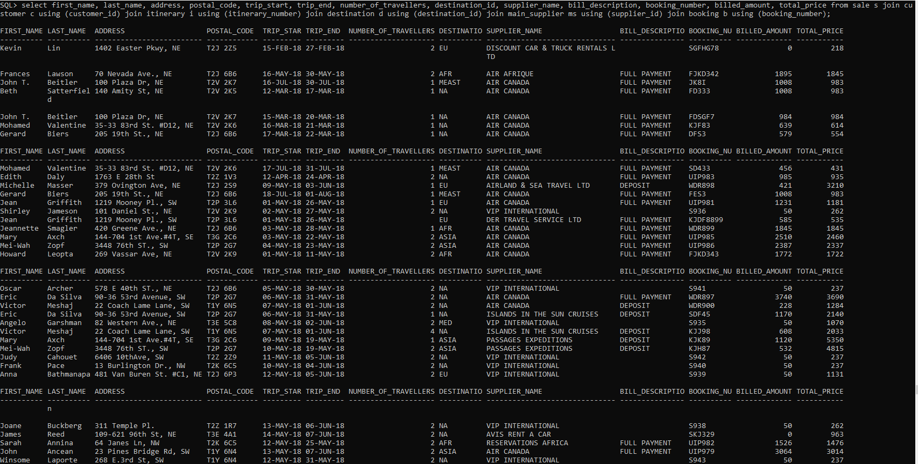

**Stored procedure**

CREATE OR REPLACE PROCEDURE sp_select_customer (p_cust_details OUT SYS_REFCURSOR)

IS

BEGIN

OPEN p_cust_details for SELECT c.customer_id, c.first_name, c.last_name, c.address, c.postal_code,

i.itinerary_number, i.trip_start, i.trip_end, i.number_of_travellers,

d.destination_id, ms.supplier_name, b.bill_description, b.booking_number,

b.billed_amount, b.total_price, cc.card_number

FROM sale s

JOIN customer c ON s.customer_id=c.customer_id

JOIN itinerary i ON s.itinerary_number=i.itinerary_number

JOIN destination d ON s.destination_id=d.destination_id

JOIN main_supplier ms ON s.supplier_id=ms.supplier_id

JOIN booking b ON s.booking_number=b.booking_number

JOIN payment p ON s.payment_id=p.payment_id

JOIN cust_credit_card cc ON p.cust_credit_card_id=cc.cust_credit_card_id;

END;

/

CREATE OR REPLACE PROCEDURE get_sale_details

IS

-- Define cursor for the query

CURSOR sale_cursor IS

SELECT c.customer_id, c.first_name, c.last_name, c.address, c.postal_code, i.itinerary_number, i.trip_start, i.trip_end, i.number_of_travellers, d.destination_id, ms.supplier_name, b.bill_description, b.booking_number, b.billed_amount, b.total_price, cc.card_number

FROM sale s

JOIN customer c ON s.customer_id=c.customer_id

JOIN itinerary i ON s.itinerary_number=i.itinerary_number

JOIN destination d ON s.destination_id=d.destination_id

JOIN main_supplier ms ON s.supplier_id=ms.supplier_id

JOIN booking b ON s.booking_number=b.booking_number

JOIN payment p ON s.payment_id=p.payment_id

JOIN cust_credit_card cc ON p.cust_credit_card_id=cc.cust_credit_card_id;

-- Declare variables for the cursor

v_customer_id sale.customer_id%TYPE;

v_first_name customer.first_name%TYPE;

v_last_name customer.last_name%TYPE;

v_address customer.address%TYPE;

v_postal_code customer.postal_code%TYPE;

v_itinerary_number itinerary.itinerary_number%TYPE;

v_trip_start itinerary.trip_start%TYPE;

v_trip_end itinerary.trip_end%TYPE;

v_number_of_travellers itinerary.number_of_travellers%TYPE;

v_destination_id destination.destination_id%TYPE;

v_supplier_name main_supplier.supplier_name%TYPE;

v_bill_description booking.bill_description%TYPE;

v_booking_number booking.booking_number%TYPE;

v_billed_amount booking.billed_amount%TYPE;

v_total_price booking.total_price%TYPE;

v_card_number cust_credit_card.card_number%TYPE;

BEGIN

-- Open the cursor

OPEN sale_cursor;

-- Loop through the cursor and output the results

LOOP

FETCH sale_cursor INTO v_customer_id, v_first_name, v_last_name, v_address, v_postal_code, v_itinerary_number, v_trip_start, v_trip_end, v_number_of_travellers, v_destination_id, v_supplier_name, v_bill_description, v_booking_number, v_billed_amount, v_total_price, v_card_number;

EXIT WHEN sale_cursor%NOTFOUND;

DBMS_OUTPUT.PUT_LINE(v_customer_id || ', ' || v_first_name || ' ' || v_last_name || ', ' || v_address || ', ' || v_postal_code || ', ' || v_itinerary_number || ', ' || v_trip_start || ', ' || v_trip_end || ', ' || v_number_of_travellers || ', ' || v_destination_id || ', ' || v_supplier_name || ', ' || v_bill_description || ', ' || v_booking_number || ', ' || v_billed_amount || ', ' || v_total_price || ', ' || v_card_number);

END LOOP;

-- Close the cursor

CLOSE sale_cursor;

END;

/

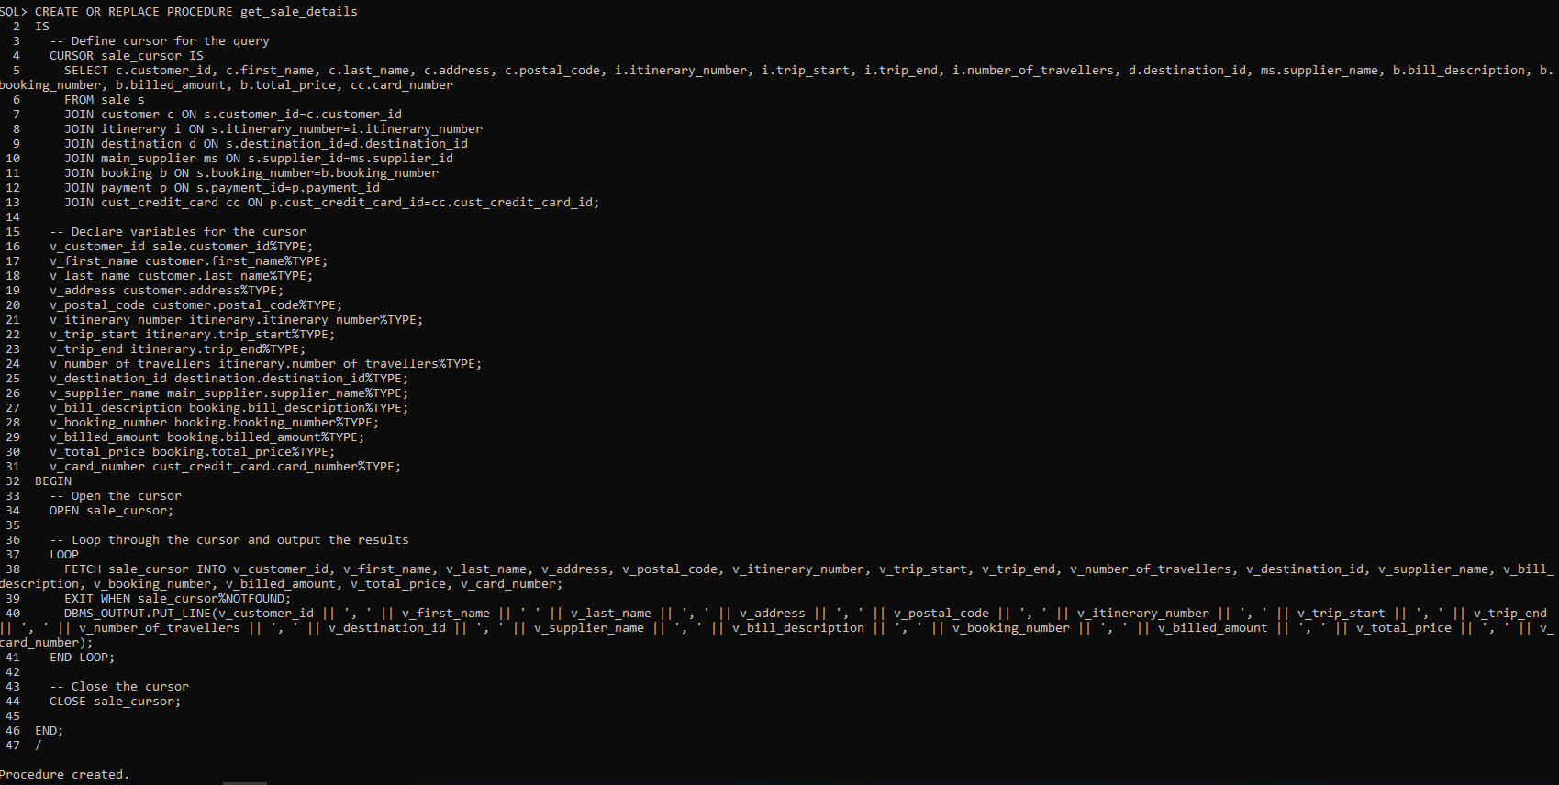

SQL> SET SERVEROUTPUT ON;

SQL> EXEC get_sale_details;

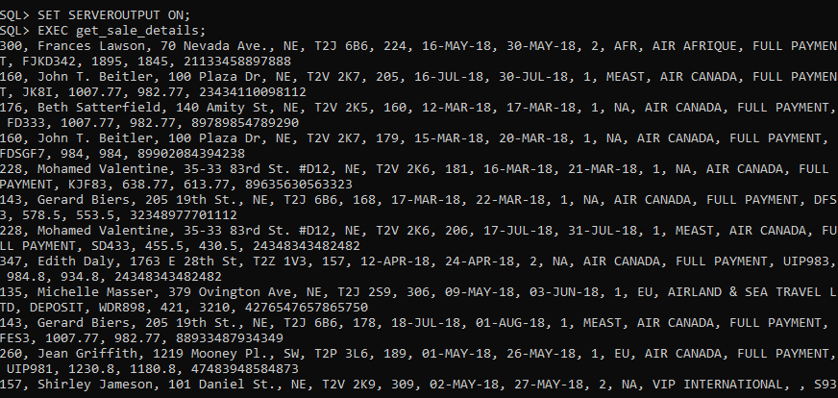

1. **Commission report script**

select * from commission;

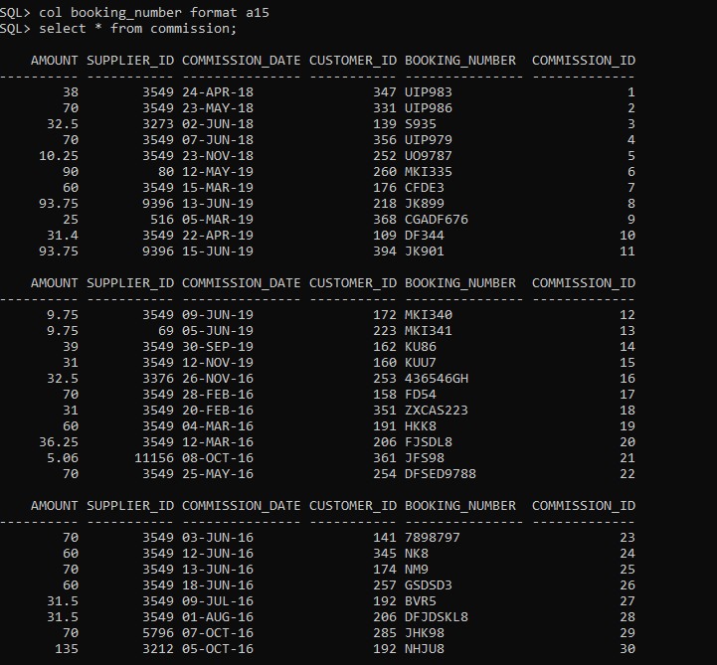

1. **Entry of a new customer**

SQL> CREATE SEQUENCE seq_customers START WITH 403 INCREMENT BY 1 NOCACHE NOCYCLE;

ACCEPT first_name PROMPT "Enter first name: "

ACCEPT last_name PROMPT 'Enter last name: '

ACCEPT email PROMPT 'Enter email: '

ACCEPT home_phone PROMPT 'Enter phone number: '

ACCEPT business_phone PROMPT 'Enter business phone: '

ACCEPT date_of_birth PROMPT 'Enter DOB (Example 24-DEC-1998: '

ACCEPT address PROMPT 'Enter address: '

ACCEPT city PROMPT 'Enter city: '

ACCEPT postal_code PROMPT 'Enter postal code: '

ACCEPT province PROMPT 'Enter province: '

ACCEPT country PROMPT 'Enter country: '

INSERT INTO customer (customer_id, first_name, last_name, email, home_phone, business_phone, date_of_birth, address, city, postal_code, province, country) VALUES (seq_customers.NEXTVAL, '&first_name', '&last_name', '&email', 'home_phone', '&business_phone', '&date_of_birth', '&address', '&city', '&postal_code', '&province', '&country');

@C:\Temp\addcustomer.sql



select * from customer where first_name = 'Femi';

